Playground Rules

Everyone can play and everyone cleans up
Ladders are for up

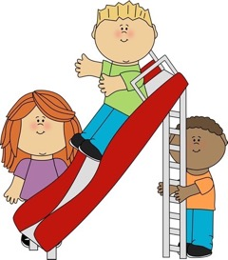
Slides are for down
Slide only on your bottom & one at a time
Balls are for bouncing, not kicking
Share and be kind to one another

Classroom Rules
Listen and follow directions quickly

Use kind and helping hands

Use quiet voices and walking feet

Learn, be safe, and have fun
Cafeteria Rules: Kindergarten
Find and sit at your class table
Stay seated (unless throwing your trash away)

Use quiet and kind voices

Clean up your tray or trash when finished

Raise your hand if you need help, and remember to say thank you to the nice cafeteria ladies

