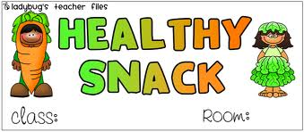

Please **do not bring items that are high in sugar and/or low in nutritional value**. Items such as Fruit by the Foot and fruit snacks do not contain fruit and are high in sugar. It is difficult for students to focus when they are having a “sugar high”. Also, students are often “still hungry” after consuming such snacks.

**Snack Suggestions Include:**

string cheese grapes graham crackers

hard boiled eggs sliced oranges Teddy Grahams

Go-gurts bananas pretzels

apple sauce w/spoons any fresh sliced fruit muffins

fresh sliced veggies trail mix crunchy granola bars

** please check with the teacher before bringing items that contain nuts.

We often have students with nut allergies and we want to keep them safe.

**Pease DO NOT bring:**

pudding cookies frosted items fruit snacks/roll-ups

jello candy donuts any other sugary item

We want to take very good care of our precious Kinders, so these unhealthy items will not be distributed if they are sent in. They will be returned to you.

I find that providing snacks that contain protein in the mornings improves the students’ ability to focus throughout the morning. By the afternoon students are very hungry and enjoy sliced fruits or graham crackers to hold them over until lunchtime.

Attached you will find the snack calendar for August and September. Please

plan to bring an early morning and late morning snack for ____ children on your assigned snack day. The snacks should be healthy choices that are individually packaged. Students love to pass out the snack on their snack day and this keeps our snacks germ free. ☺