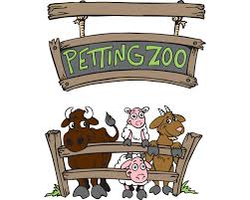
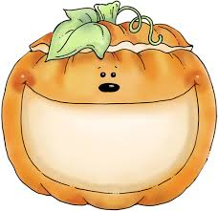
It’s time for a field trip to
Hurst Ranch

The TK and Kindergarten classes will be going on a field trip to Hurst Ranch on Monday, October 30th. We will board the buses at 8:40 A.M. and will return to school around 11:15 A.M..

The cost for the trip is $4.00 for each child. This pays for some time in the petting zoo, a ride on the train, fun in a hay maze, a pumpkin for each child, and our bus transportation. (Just let us know if this is a problem, all children will participate, of course!)

Please dress your child appropriately for the weather and wear closed toe shoes. Bring a backpack to school this day so your child can carry their pumpkin home safely.

Parent Helpers: Each class would like to have 4-5 parents to accompany us. Parent helpers need not pay to attend (Pumpkins will be for the children only). This is a special trip for TK and Kindergarteners, so siblings will not be able to attend. If you would like to volunteer, please fill out the volunteer permission slip, and let your child’s teacher know. Each teacher will need a couple of parents to ride the bus.

If you can volunteer to bring a fun fall snack and drink for our class to enjoy at the picnic area on this day (For example: Pumpkin muffins, apple juice, oatmeal cookies) please let your child’s teacher know.
_ _ _ _ _ _ _ _ _ _ _ _ _ _ _ _ _ _ _ _ _ _ _ _ _ _ _ _
Please fill this out and return it with the permission slip and payment.

Enclosed is my $_______ for ________________________________.
Child’s Name

Enclosed is the signed permission slip filled in completely.

I can bring a snack. I would like to bring________. Phone:

I can bring drinks. I would like to bring __________. Phone:
Parent Name:________________________________________________

